In Class 1 Admissions Data Hayden Patterson

How many observations are in the data set? 1230

How many variables? 5

How many people are admitted? 352+304=656

What fraction of people are admitted? 53%

How many females are admitted? 352

How many males are admitted? 304

What proportion of females are admitted? 57%

What proportion of males are admitted? 49%

What proportion of admitted students are female? 54%

Make a polished, stacked bar chart showing the count of each gender admitted and denied. Copy the graph below.
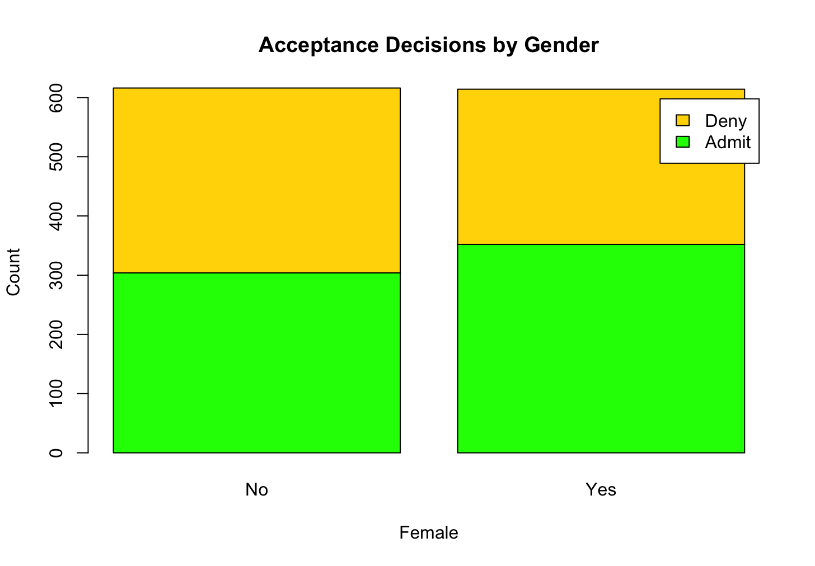

Based on the Regression eq1, does Gender matter?
No gender has no impact when considering high school GPA and SAT score.
The gender dummy variable is insignificant.

Summarize your findings in 3-4 sentences. Comment on overall admittance rates and admittance by gender and the regression output.

A study for a school was completed with 1230 observations to see what effected enrollment the most. The variables were decision (Admit/Deny), Female (Yes/No), HSGPA, and SAT. Overall 53% of applicants (656 of 1,230) were admitted. Looking at admittance by gender alone, females were admitted at a higher rate then males (57% vs. 49%), and females made up 54% of all admitted students. However, once HSGPA and SAT scores are controlled for in the regression, the male dummy variable is statistically insignificant, thus gender itself has no measurable effect on admission decisions, after accounting for academic qualifications. This suggests the raw gender gap admittance rates isn’t evidence of gender bias in the decision process but instead reflects differences in the academic credentials (HSGPA and SAT) between male and female applicants in this data set.

